**AIM- Write a program to sort n numbers using Selection sort technique**

**Source code-**

**i)Using array**

#include <stdio.h>

void selection_sort();

int a[30], n;

void main()

{

int i;

printf("\nEnter size of an array: ");

scanf("%d", &n);

printf("\nEnter elements of an array:\n");

for(i=0; i<n; i++)

scanf("%d", &a[i]);

selection_sort();

printf("\n\nAfter sorting:\n");

for(i=0; i<n; i++)

printf("\n%d", a[i]);

getch();

}

void selection_sort()

{

int i, j, min, temp;

for (i=0; i<n; i++)

{

min = i;

for (j=i+1; j<n; j++)

{

if (a[j] < a[min])

min = j;

}

temp = a[i];

a[i] = a[min];

a[min] = temp;

}

}

**OUTPUT-**

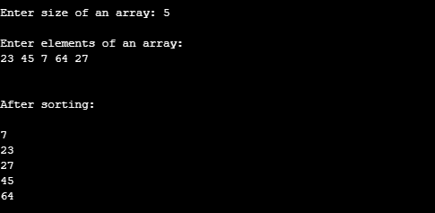

**ii) Using recursion**

#include <stdio.h>

void selection(int [], int, int, int, int);

int main()

{

int list[30], size, temp, i, j;

printf("Enter the size of the list: ");

scanf("%d", &size);

printf("Enter the elements in list:\n");

for (i = 0; i < size; i++)

{

scanf("%d", &list[i]);

}

selection(list, 0, 0, size, 1);

printf("The sorted list in ascending order is\n");

for (i = 0; i < size; i++)

{

printf("%d ", list[i]);

}

return 0;

}

void selection(int list[], int i, int j, int size, int flag)

{

int temp;

if (i < size - 1)

{

if (flag)

{

j = i + 1;

}

if (j < size)

{

if (list[i] > list[j])

{

temp = list[i];

list[i] = list[j];

list[j] = temp;

}

selection(list, i, j + 1, size, 0);

}

selection(list, i + 1, 0, size, 1);

}

}

**OUTPUT-**

